**Project Name:** A Comparative Study of Statistical and Machine Learning Models

**Name:** Md.Ghalib Faruqe

**Department:** Computer Science

This study assesses the effectiveness of statistical and machine learning models in understanding how traffic-related factors influence academic performance. It analyzes a dataset of 80 survey responses that explore the connections between traffic frequency, stress, transportation costs, and academic outcomes. The analysis includes techniques such as Ordinary Least Squares (OLS) regression, Poisson regression, Bayesian Ridge regression, and machine learning methods like Support Vector Regression, Ridge Regression, Random Forest, and XGBoost. Data preprocessing steps involved MinMax scaling for numerical features and encoding for categorical variables. Model performance is evaluated using R², Mean Squared Error (MSE), and Mean Absolute Error (MAE).

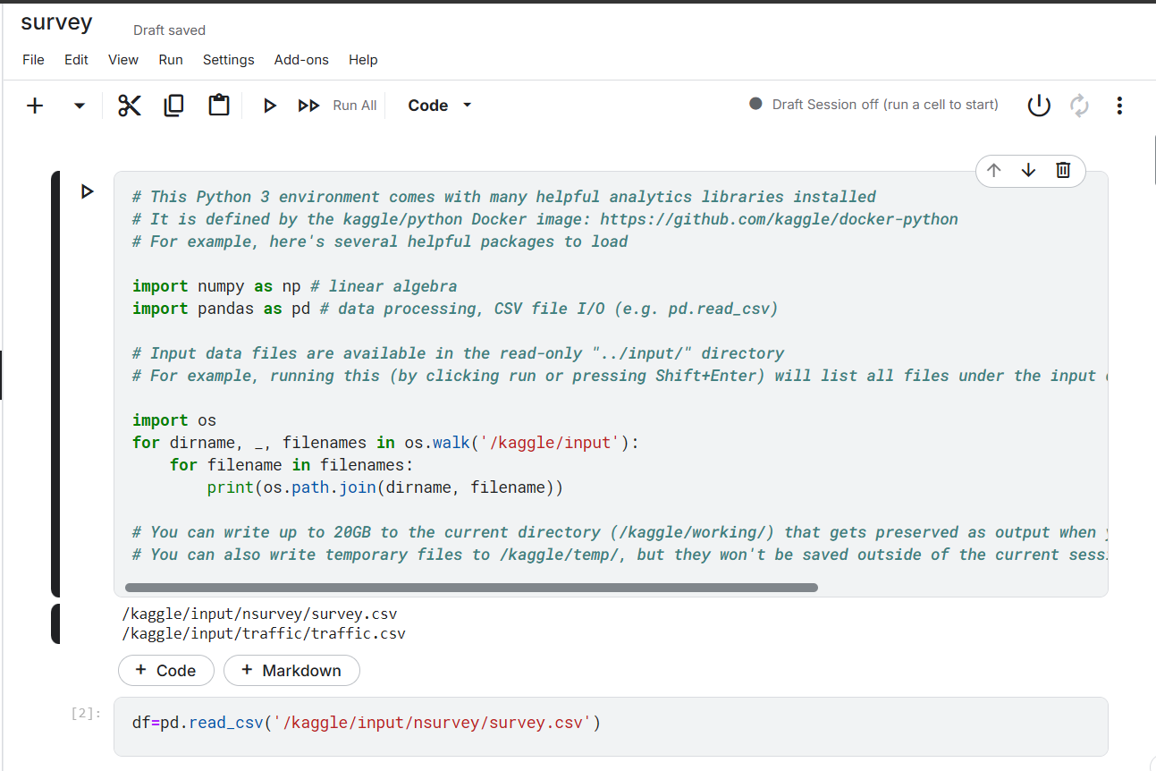

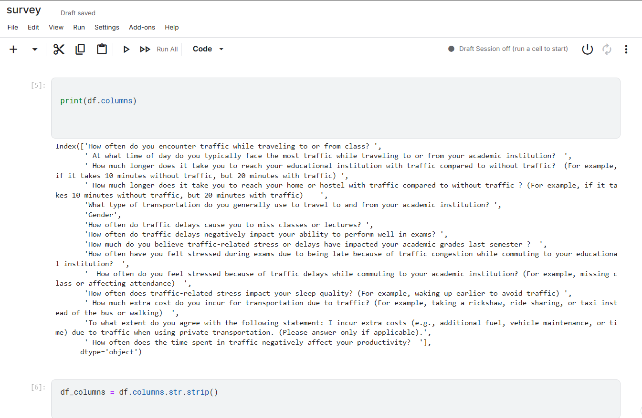

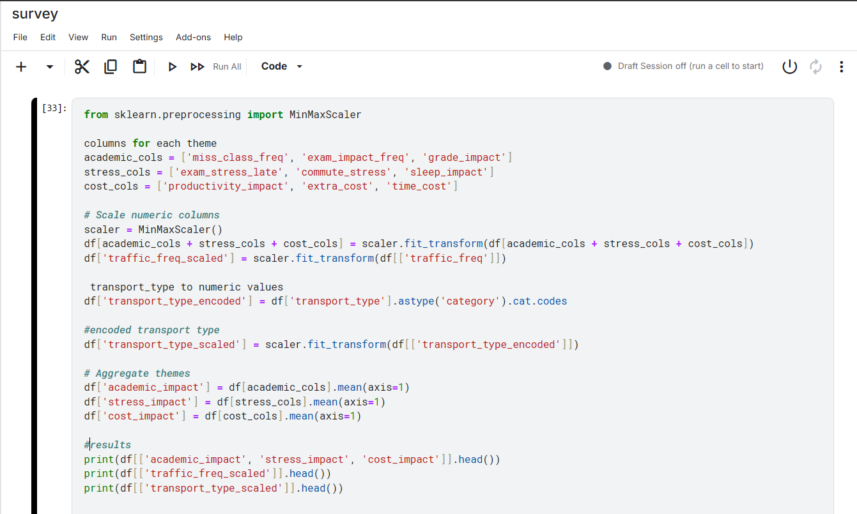

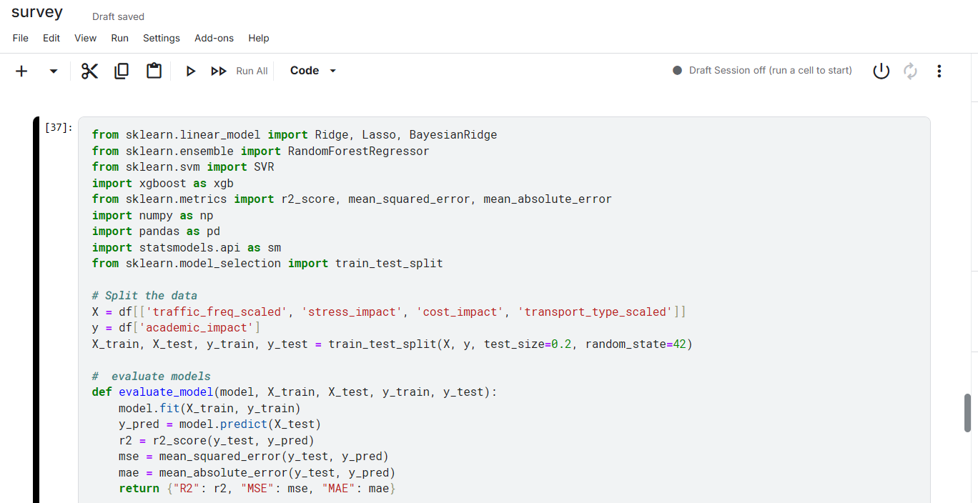

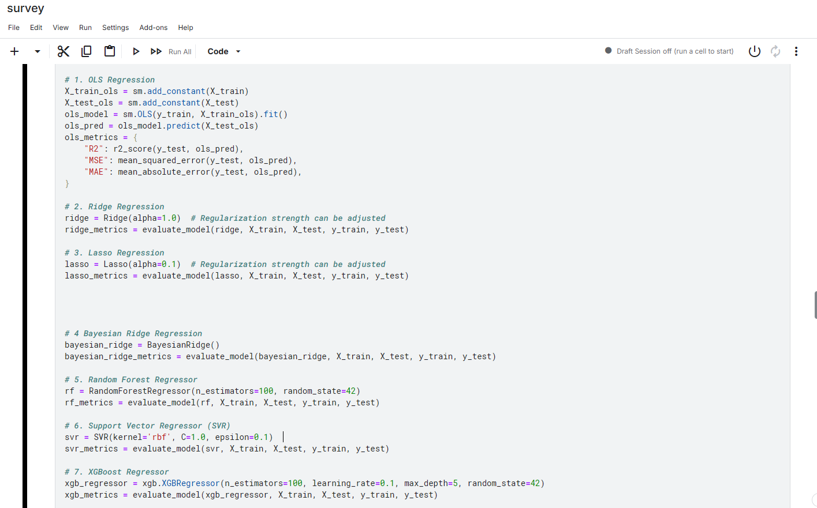

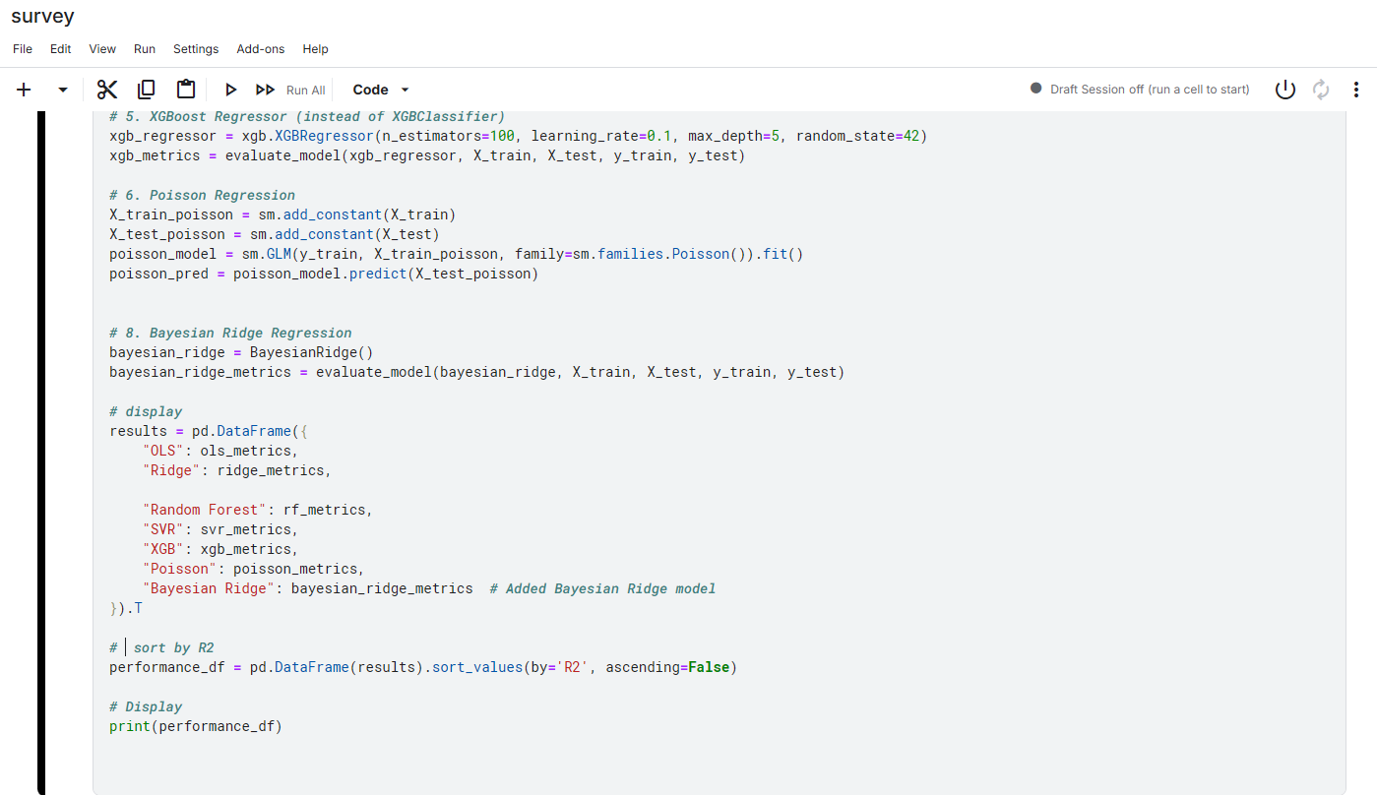

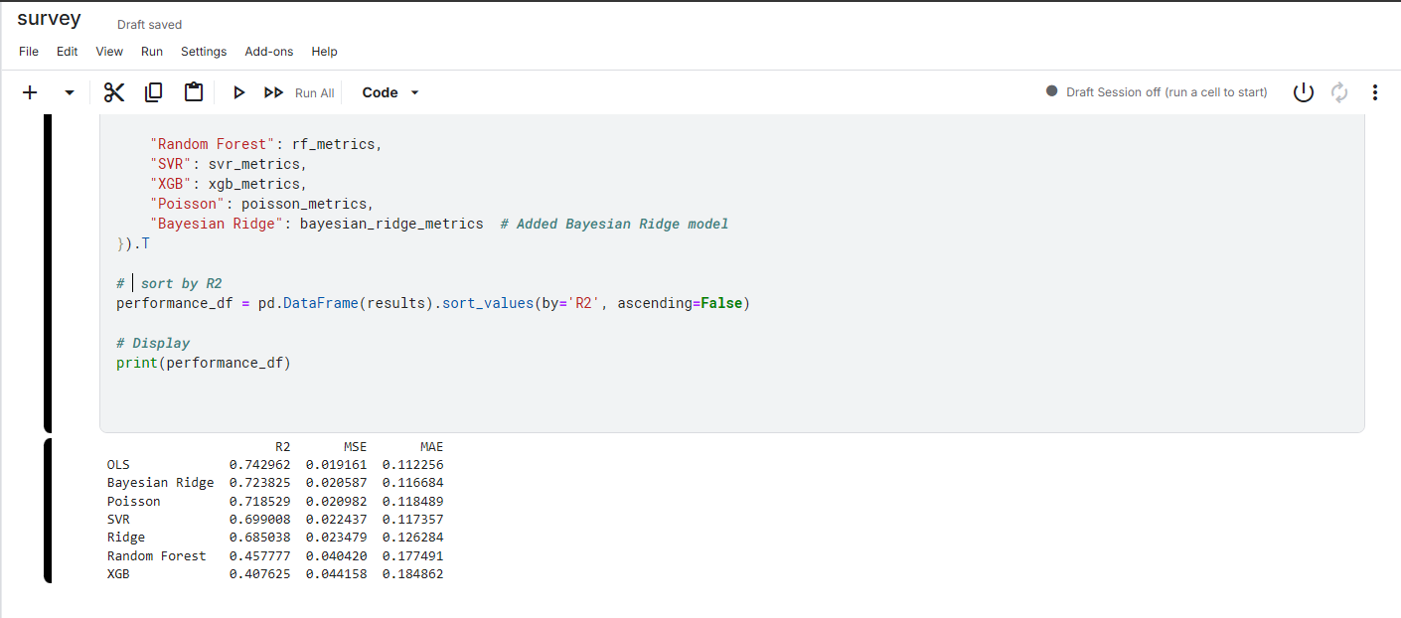

The analysis concentrated on metrics like missed classes and exam-related stress, with model performance assessed through R², Mean Squared Error (MSE), and Mean Absolute Error (MAE). The Ordinary Least Squares (OLS) regression model outperformed others, achieving an R² of 0.743, MSE of 0.0192, and MAE of 0.1123. Additionally, both Bayesian Ridge and Poisson regression models showed strong performance in the analysis.